

MARMARA UNIVERSITY
FACULTY OF ENGINEERING
PHYS 1103.4
PHYSICS LABORATORY

EXPERIMENT 4

PROJECTILE MOTION
Section Number: 7
Group Number: 8
Submitted to: Arş. Göv. Hüseyin YALTIRIK
Due Date: 15.12.2021

 | Dept | Student Id | Name Surname | Contribution
1 | EE | 150720062 | MEHMET ALİ KAMALAK | Conclusion, theory, references, purpose, calculations

İÇİNDEKİLER

Purpose: 3
THEORY : 3
CALCULATION : 3
For Experiment: 3
CONCLUSION : 7
REFERENCES : 7

Purpose:
In this experiment, we videotaped the ball by making a horizontal shot movement from somewhere. We got some data and graphs by uploading these videos to the tracker.

THEORY :
In this experiment, I record a ball shooting horizontally from a high place. then i upload this video to tracker and I get some data. I thought that the acceleration would be constant since there was no change in the environment, and when we consider the values ​​on the tracker, I observed that the accelerations were almost the same.

CALCULATION :

For Experiment:

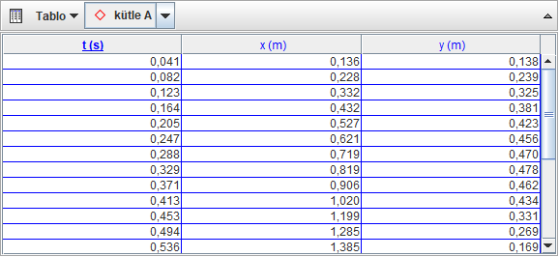

t(s) | x(m) | y(m) | t^2(s^2)
0,041 | 0,136 | 0,138 | 0,001681
0,082 | 0,228 | 0,239 | 0,006724
0,123 | 0,332 | 0,325 | 0,015129
0,164 | 0,432 | 0,381 | 0,026896
0,205 | 0,527 | 0,423 | 0,042025
0,247 | 0,621 | 0,456 | 0,061009
0,288 | 0,719 | 0,47 | 0,082944
0,329 | 0,819 | 0,478 | 0,108241
0,371 | 0,906 | 0,462 | 0,137641
0,413 | 1,02 | 0,434 | 0,170569
0,453 | 1,199 | 0,331 | 0,205209
0,494 | 1,285 | 0,269 | 0,244404
0,536 | 1,385 | 0,169 | 0,287296
0,578 | 1,475 | 7,70E-02 | 0,334084
0,62 | 1,661 | -0,182 | 0,3844
0,661 | 1,759 | -0,347 | 0,436921
0,703 | 1,837 | -0,492 | 0,494209
0,744 | 0,932 | -0,673 | 0,553536
0,786 | 2,107 | -1,046 | 0,617796
0,827 | 2,209 | -1,302 | 0,683929
0,869 | 2,276 | -1,492 | 0,755161
0,91 | 2,357 | -1,755 | 0,8281
0,952 | 2,467 | -2,055 | 0,906304
0,993 | 2,629 | -2,575 | 0,986049

y(m) | t(s) | v(m/s) | a(m/s^2)
0,138 | 0,041 | 3,36585 | 9,6
0,239 | 0,082 | 2,91463 | 9,6
0,325 | 0,123 | 2,64227 | 9,6
0,381 | 0,164 | 2,32331 | 9,6
0,423 | 0,205 | 2,06341 | 9,6
0,456 | 0,247 | 1,84615 | 9,6
0,47 | 0,288 | 1,63194 | 9,6
0,478 | 0,329 | 1,45288 | 9,6
0,462 | 0,371 | 1,24528 | 9,6
0,434 | 0,413 | 1,05084 | 9,6
0,331 | 0,453 | 0,73068 | 9,6
0,269 | 0,494 | 0,54453 | 9,6
0,169 | 0,536 | 0,31529 | 9,6
7,70E-02 | 0,578 | 0,13321 | 9,6
-0,182 | 0,62 | -0,29354 | 9,6
-0,347 | 0,661 | -0,52496 | 9,6
-0,492 | 0,703 | -0,69985 | 9,6
-0,673 | 0,744 | -0,90456 | 9,6
-1,046 | 0,786 | -1,33078 | 9,6
-1,302 | 0,827 | -1,57436 | 9,6
-1,492 | 0,869 | -1,71691 | 9,6
-1,755 | 0,91 | -1,92857 | 9,6
-2,055 | 0,952 | -2,15861 | 9,6
-2,575 | 0,993 | -2,59315 | 9,6

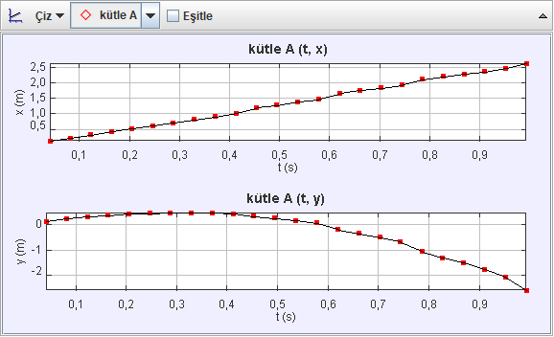

CONCLUSION :
In this experiment, I learned the values ​​of an object that shoots obliquely. I was thinking that the acceleration should be constant since I did not change the environment while doing the experiment. After obtaining some data I found that the acceleration values ​​for each moment are almost the same.

REFERENCES :
Edmodo experiment 4 pdf

